**Team Number:** 13-02

**Team Name:** Swift Agility

**Team Member:**

Name: Johnny Wilcox

1. GitHub: Johnny-Wilcox1
2. Email: [Anthony.WilcoxJr@colorado.edu](mailto:Anthony.WilcoxJr@colorado.edu)

Name: Suhana Zeutzius

1. GitHub: suhanazeutzius
2. Email: [suze5824@colorado.edu](mailto:suze5824@colorado.edu)

Name: Alex McDonald

1. GitHub: standardProton
2. Email: almc8368@colorado.edu

Name: Aniket Chauhan

1. GitHub: anch5121
2. Email: anch5121@colorado.edu

Name: Tyler Kivelson

1. GitHub: teeck111
2. Email: tyki4030@colorado.edu

Name: Grayson Richard

1. GitHub: ouefsoupe
2. Email: grri8788@colorado.edu

**Application Name:** GenerAte

**Application Description:**

Our application is designed to support home cooks in discovering new and innovative recipes. By leveraging generative AI technology along with customizable ingredients and nutritional information, our app generates unique recipes tailored to individual preferences.

Beyond just providing recipes, we aim to build a thriving community around cooking. Users can not only explore a wide variety of recipes but also share their own creations, like and save recipes, and engage in discussions through comments. This community-driven approach fosters a collaborative environment where home cooks can learn, inspire, and connect with others who share their passion for cooking.

**Vision Statement:** "Empowering home cooks worldwide with personalized, innovative recipes and a vibrant culinary community”

**Version Control:**Repository is set up with the necessary folders (10 points)

**Development Methodology:**A development methodology is decided upon and the Github project is set up with epics and user stories (15 points)

**Communication Plan:** Our team made a Discord channel for communication and can meet on **Wednesday** afternoons at 1:45 pm.

**Meeting Plan:** Our scrum meeting will be with our TA at 2:30 pm every **Tuesday** afternoon over Zoom

**Use Case Diagram:** The use case diagram specifies a few use cases (15 points)

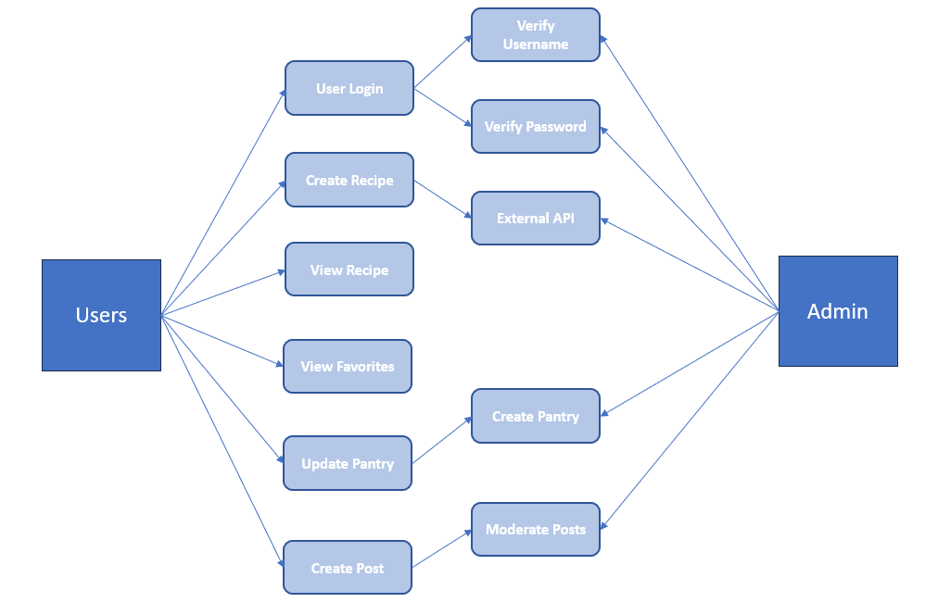

**Wireframes:**Wireframes for UIs are included (15 points)

